**BIG MOUNTAIN RESORT**

What is the best solution, Big Mountain resort can adopt to increase the profit margin and compensate for the additional 1.54 million $ operating cost for the new chair lift installed, by capitalizing on its facilities without undermining the ticket price or support a higher ticket price for this season?

Resorts are free to set whatever price they like since ticket pricing is not determined by any set of parameters as such. However, resorts operate within a market, where people pay more for certain facilities and less for others. The dominant features with the random forest regression modelling were fastQuads, Runs, Snow_making_ac and vertical drop. Therefore, these features may have an impact on ticket pricing.

The business has shortlisted few options given below to evaluate:

1. Permanently closing down up to 10 of the least used runs. This doesn't impact any other resort statistics.
2. Increase the vertical drop by adding a run to a point 150 feet lower down but requiring the installation of an additional chair lift to bring skiers back up, without additional snow making coverage.
3. Same as number 2, but adding 2 acres of snow making cover.
4. Increase the longest run by 0.2 mile to boast 3.5 miles length, requiring an additional snow making coverage of 4 acres.

The expected number of visitors over the season is 350,000 and, on average, visitors ski for five days. The Resort has recently installed an additional chair lift to help increase the distribution of visitors across the mountain. This additional chair increases their operating costs by $1,540,000 this season. Evaluating each option on the pricing model, the below results are found:

1. Closing 1 run will not impact the ticket price much, but closing any further runs will add loss in the ticket price and hence the revenue, as shown in the below plot.

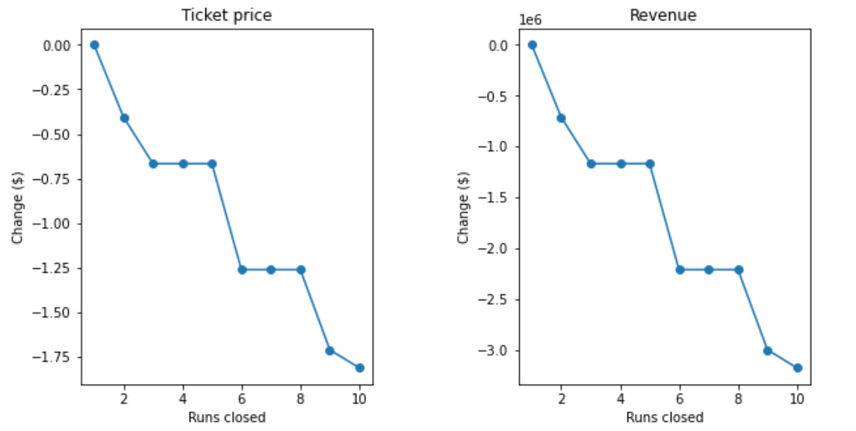

1. This option increases the ticket price by $1.99. Over the season, this could be expected to amount to $3,474,638 of revenue. Removing the operational cost for installing the additional chair this season, the revenue amounts to $ 1,934,638.
2. The third scenario helps increase the ticket price and revenue rounding off exactly same as the option 2. There is no drastic change in the output and hence cost of adding 2 acres of snow making area will only reduce the profit further. We would rather opt for the second option of increasing vertical drop by adding a run to a point 150 feet lower down and additional chair lift, which has already been installed by Big Mountain.
3. Increasing the longest run by 0.2 mile to boast 3.5 miles length, requiring an additional snow making coverage of 4 acres has no changes in the ticket pricing or revenue.

Looking at all four scenarios, the best would be to go with scenario 2. Scenario 1 can also be considered with caution.